The Download API is used to wait for file to be downloaded after link or button is clicked and allows it to be saved at specified path
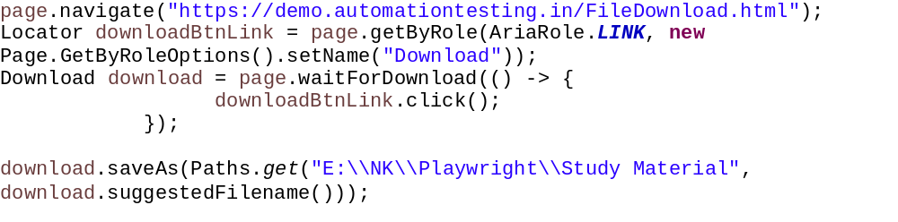
Sr. No. | Method | Use / Purpose | Code Example
1 | cancel() | Cancels the current download process. If the download fails or is canceled, its failure status resolves to 'canceled'. | download.cancel();
2 | createReadStream() | Returns the downloaded file payload as a Java InputStream so you can read its content dynamically without saving it first. | InputStream is = download.createReadStream();
3 | delete() | Deletes the temporary file created by the browser during the download session. | download.delete();
4 | failure() | Returns the download failure error as a String if the process failed, or null if it succeeded. | String error = download.failure();
5 | page() | Returns the parent Page object that initiated or owns this particular download. | Page parentPage = download.page();
6 | path() | Returns the absolute local file Path for the downloaded file. Throws an exception if the file is remote or failed. | Path localPath = download.path();
7 | saveAs(Path path) | Copies the downloaded temporary file to a permanent, specified local directory path. | download.saveAs(Paths.get("C:/downloads/report.pdf"));
8 | suggestedFilename() | Retrieves the file name suggested by the browser (usually defined via HTTP headers or the source URL). | String fileName = download.suggestedFilename();
9 | url() | Returns the original HTTP/HTTPS download URL from which the file was fetched. | String downloadUrl = download.url();

